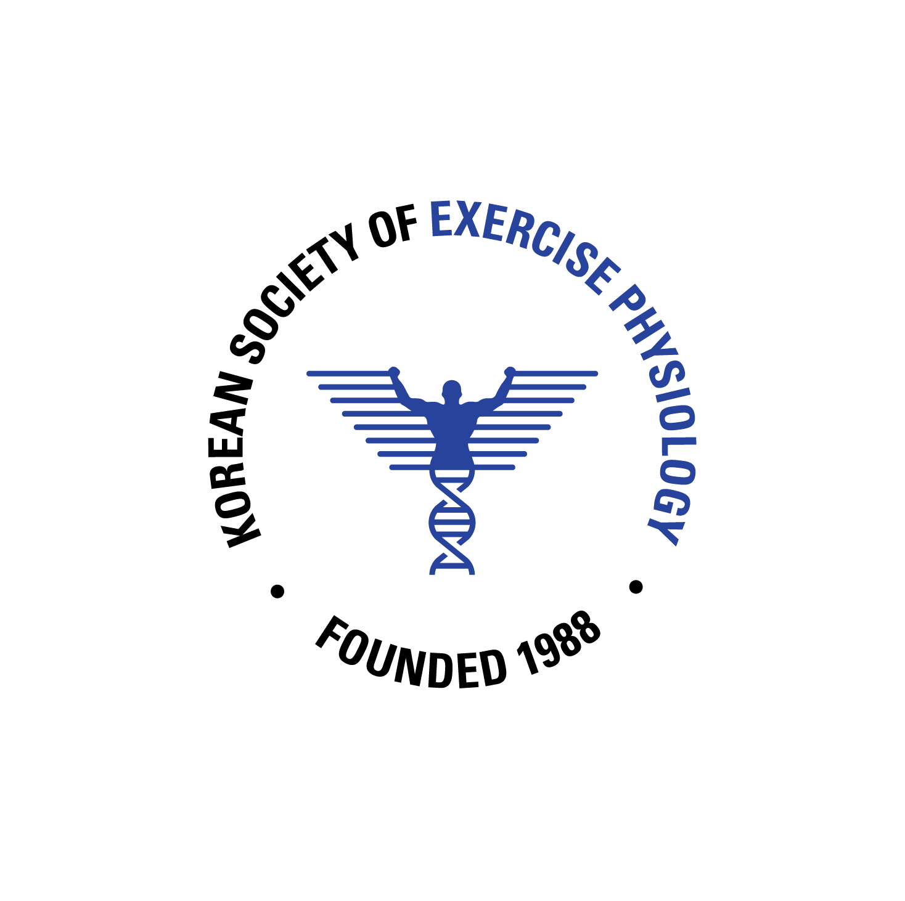 | 2021 International Conference of the KSEP  Poster Abstract Presentation Guidelines
Submission Deadline
The abstract submission deadline is 30, July, 2021.
The poster presentation video (*mp4.) submission deadline is 20. Aug, 2021.

E-poster Abstract Presentation Guidelines
· E-poster presentations must be prepared in Microsoft Power Point.
· E-poster presentation files must be submitted E-mail (exephysio1@hanmail.net).
· E-poster abstract presentations must be consistent with the contents of the prepared abstract: including an introduction, methods, results, and conclusions.
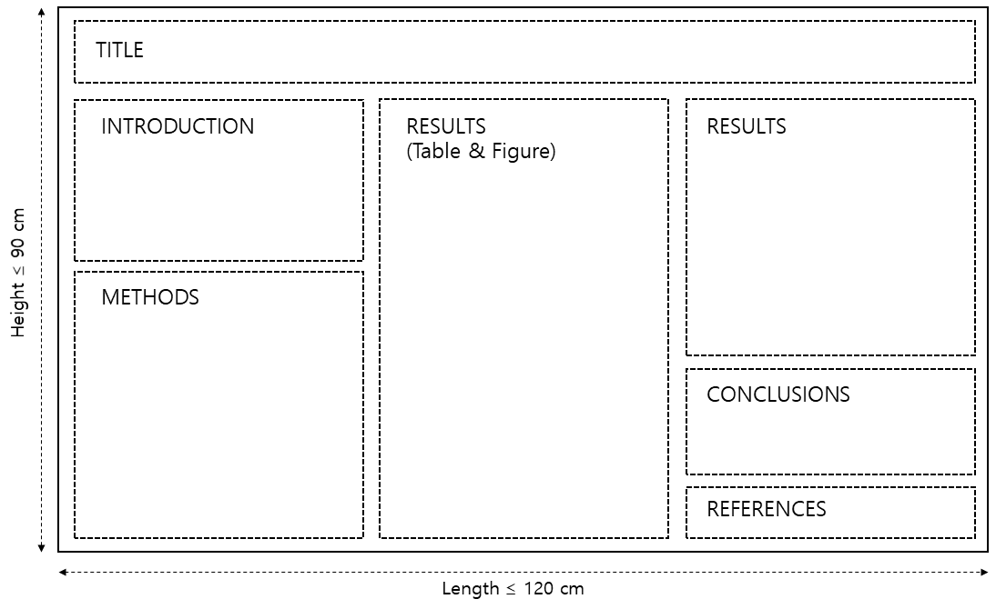
· Recommends the following layout as a general guideline for all E-poster presentations:
Title of presentation: Please choose a brief title (maximum of 100 characters) that clearly indicates the content of the research. Please avoid abbreviations in the title. Abbreviations may be used in the text if they are defined when first used.
Abstract Format and Instruction for the International Conference of the Korean Society of Exercise Physiology
Title font size: 12. Font style: Arial.
The first letter should be capitalized except for determiners.
(제목 글자크기 12. 글자모양 Arial. 관사/조사 등을 제외한 단어 첫 글자는 대문자로 구성.)
Authors: Name, institution, country and email (corresponding author)
Gil-Dong Hong¹, Kenta Suzuki² and Emma Harris³*
¹Daehan University, Korea; ²Japan University, Japan; ³Lakers University, USA
Affiliation font size: 10. Font style: Arial.
Superscript * for the corresponding author.
(저자정보 글자크기 10. 글자모양 Arial. 교신저자에 * 표기.)
Abstract: Please ensure that your abstract contains no more than 300 words. Please avoid diagrams, illustrations, tables, references or graphics in the abstract. Provide maximum relevant information in the abstract and the following structure is obligatory: background, purpose, methods, results, conclusions.
BACKGROUND:
PURPOSE:
METHODS:
RESULTS:
CONCLUSIONS:
The body font size: 10. Font style: Arial.
The number of words in the main body should be below 300.
(본문 글자크기 10. 글자모양 Arial. 영어로 작성. 연구배경/목적/방법/결과/결론으로 구성. 단어수 300 이하.)
KEYWORDS: Keywords must be 5 or less.
Keywords, Must, Be, Below, Five-words (최대 5개 키워드.)
*Email correspondence: abcde@vwxyz.com Corresponding author’s email address. (교신저자 이메일.)

Please delete the instructions in red font on your abstract.
(초록 작성 시, 붉은 글씨의 설명 부분을 삭제하시기 바랍니다.)
Korean Society of Exercise Physiology TEL : 064) 754-3010 | Email : exephysio1@hanmail.net
(Example)

Abstract Example for the International Conference of the Korean Society of Exercise Physiology

Gil-Dong Hong¹, Kenta Suzuki² and Emma Harris³*
¹Daehan University, Korea; ²Ilbon University, Japan; ³Lakers University, USA

BACKGROUND: The circulating level of endothelial microparticles (EMPs), a cellular biomarker for endothelial function, is increased in most cardiovascular diseases. Enhanced integrity of mitochondria has been recognized as an emerging protective mechanism against vascular complications. Aerobic exercise-induced increased laminar shear stress (LSS) and the treatment of resveratrol (RSV) are known enhancers of mitochondrial biogenesis. PURPOSE: The purpose of this study was to determine the effect of LSS and RSV co-treatment on the improvement of vascular homeostasis examined by EMPs production. METHODS: HUVECs were exposed to LSS using a cone and plate shear device. HUVECs were treated with 20 μM RSV for 12h. Immediately following LSS exposure, HUVECs were harvested for protein analysis and cell-culture media was collected for EMPs measurement. Rotenone (Rot) and Antimycin A (AA) were used as specific mitochondrial respiratory inhibitors for Complex I and III, respectively. Western blotting technique was used to analyze protein expression. EMPs (CD31⁺/CD42⁻) production was measured by flow cytometry. RESULTS: The level of EMPs production was significantly increased by treatment of mitochondrial complex inhibitors (1.23±0.45 to 6.78±0.09 by Rot; 1.23±0.45 to 6.78±0.09 by AA; p<.05). However, EMPs production was dramatically decreased by following LSS treatment (1.23±0.45 by LSS after Rot; 6.78±0.09 by LSS after AA; p<.05), while expression level of Porin, a mitochondrial content marker, was significantly increased by LSS (0.12±0.34 to 5.67±0.89 by LSS after Rot; 0.12±0.34 to 5.67±0.89 by LSS after AA; p<.05). The expression levels of Sirt1 and PGC-1α, mitochondrial biogenesis factors, and Porin were dramatically increased by combined treatment of RSV/LSS, while the level of EMPs production was significantly decreased. CONCLUSION: The present study demonstrated that the aerobic exercise and RSV treatment can improve vascular homeostasis by the endothelial mitochondrial biogenesis.

KEYWORDS: Aerobic exercise, Laminar shear stress, Resveratrol, Mitochondrial biogenesis,
*Email correspondence: abcde@vwxyz.com

