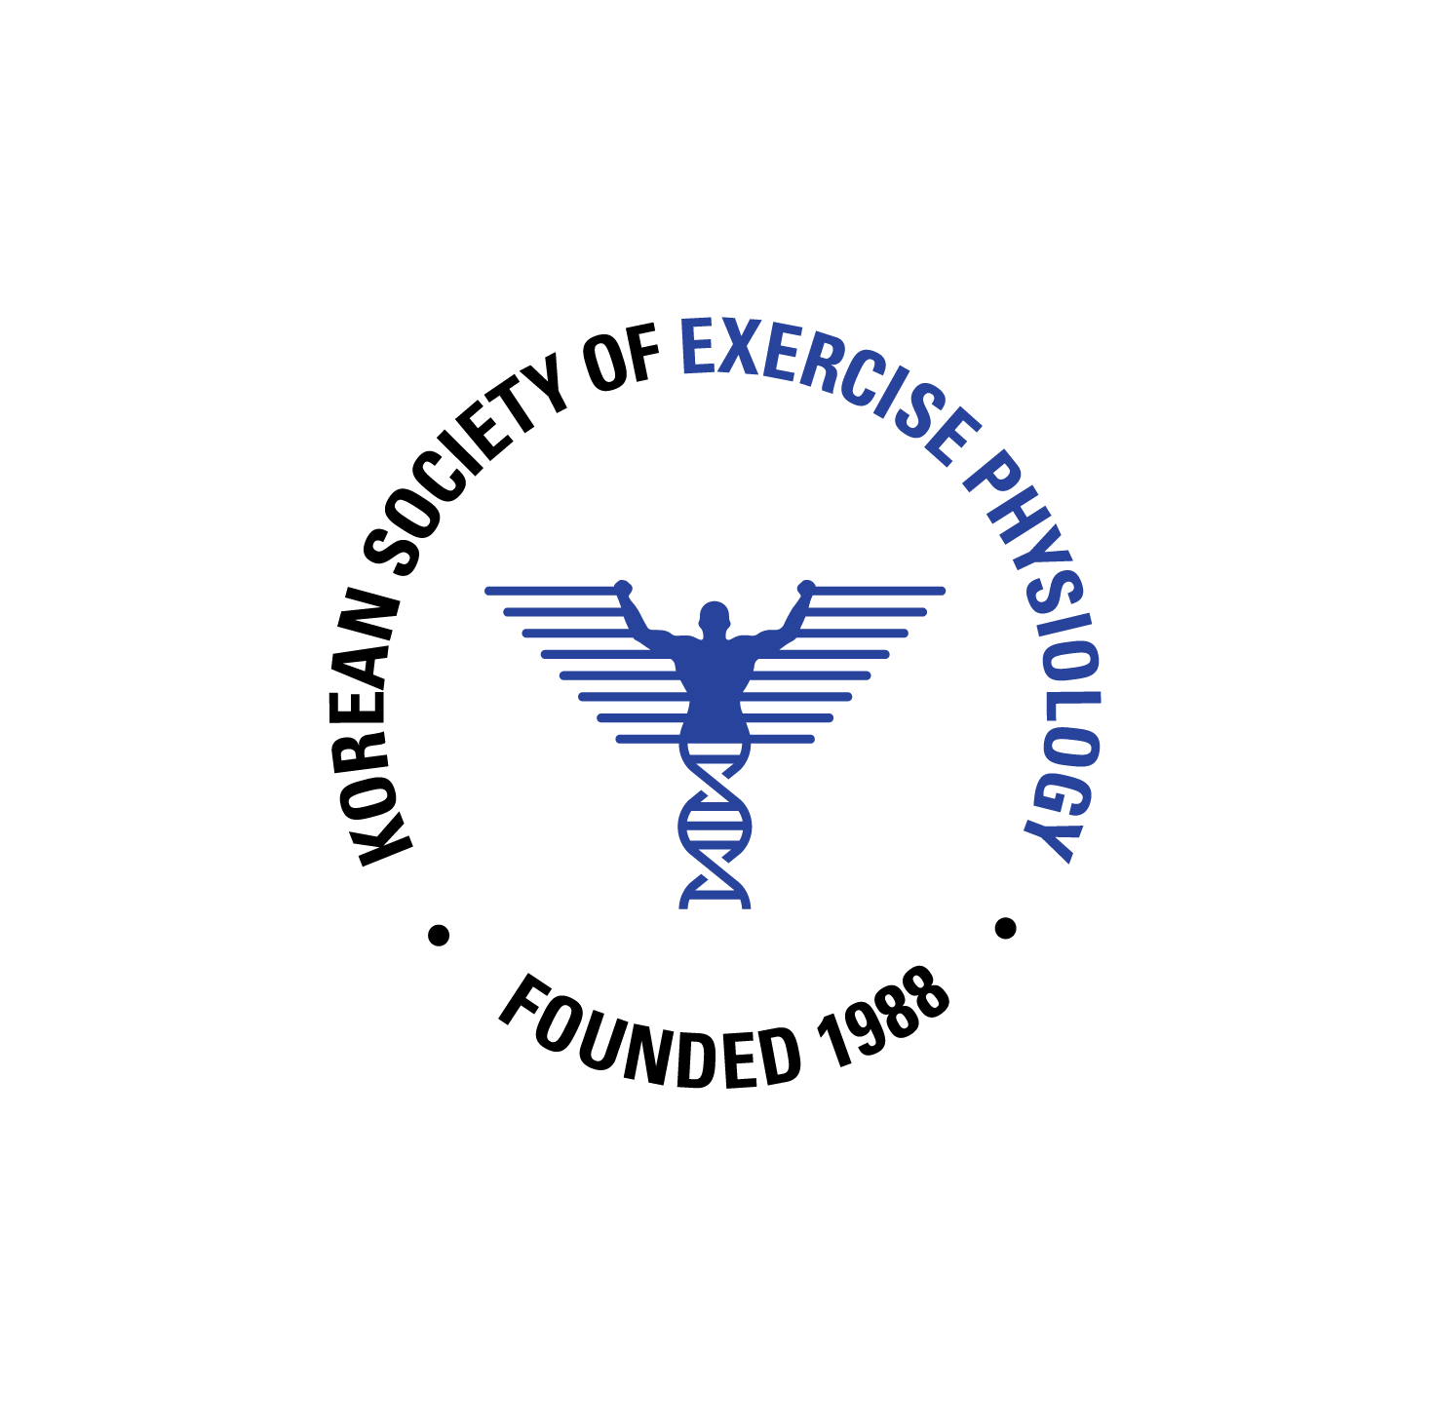 | 2026 KSEP Annual Meeting  Oral Presentation Abstract Guidelines
Submission Deadline

The abstract and submission deadline is December 31, 2025.
Curriculum Vitae (CV) submission deadline is December 31, 2025.
The presentation file (ppt) deadline is January 31, 2026.

Gil-Dong Hong
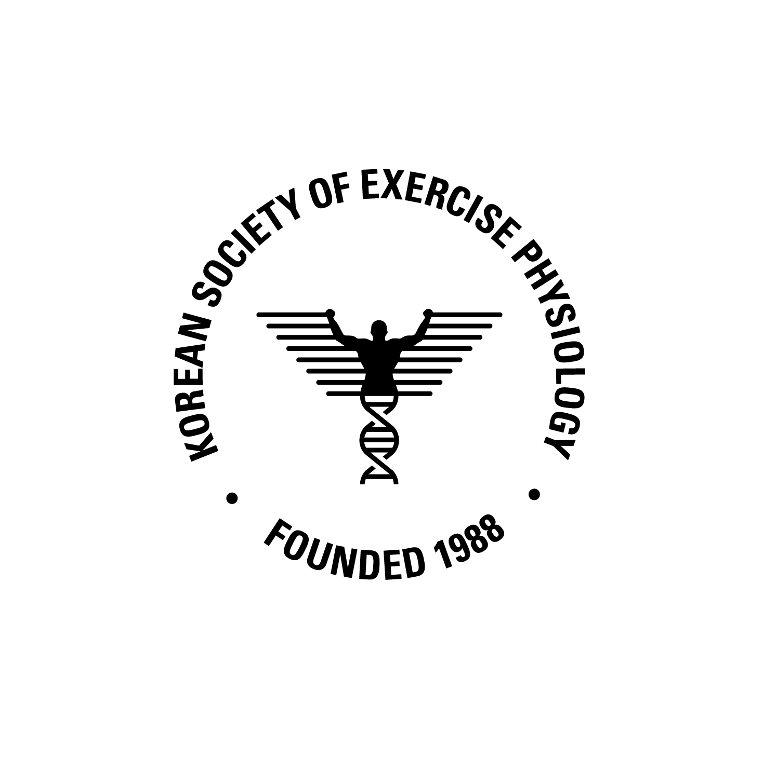Photo
Jeju National University
Laboratory of Exercise Physiology
Title _

Abstracts_ Please ensure that your abstract contains no more than 300 words. Please avoid diagrams, illustrations, tables, references or graphics in the abstract. Provide maximum relevant information in the abstract and the following structure is obligatory: background, purpose, methods, results, conclusions.

KEYWORDS: Keywords must be 5 or less.
*Email correspondence: abcde@vwxyz.com

