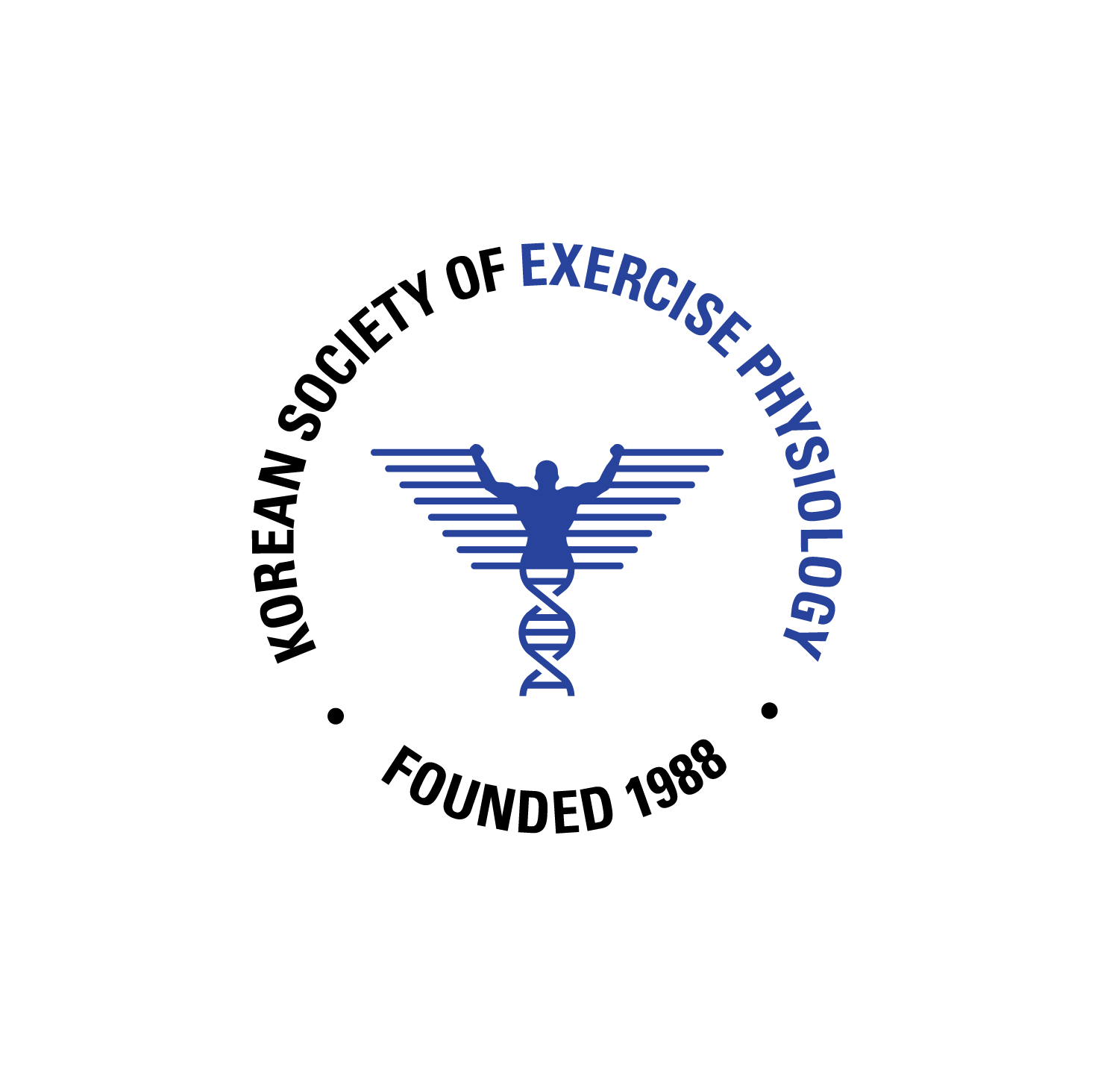 | 2026 KSEP Annual Meeting  Oral Presentation Abstract Guidelines
Submission Deadline

The abstract and submission deadline is January 25, 2026.
Curriculum Vitae (CV) submission deadline is January 25, 2026.
The presentation file (ppt) deadline is February 28, 2026.

2026 KSEP Annual Meeting
Advancing human performance bridging science and practice in exercise physiology

Dates: April 9th 2026(Thursday) -April 11th 2026 (Saturday)
Place: SONO Calm Yeosu, Korea
Supervision: Korean Society of Exercise Physiology (KSEP)

Title _
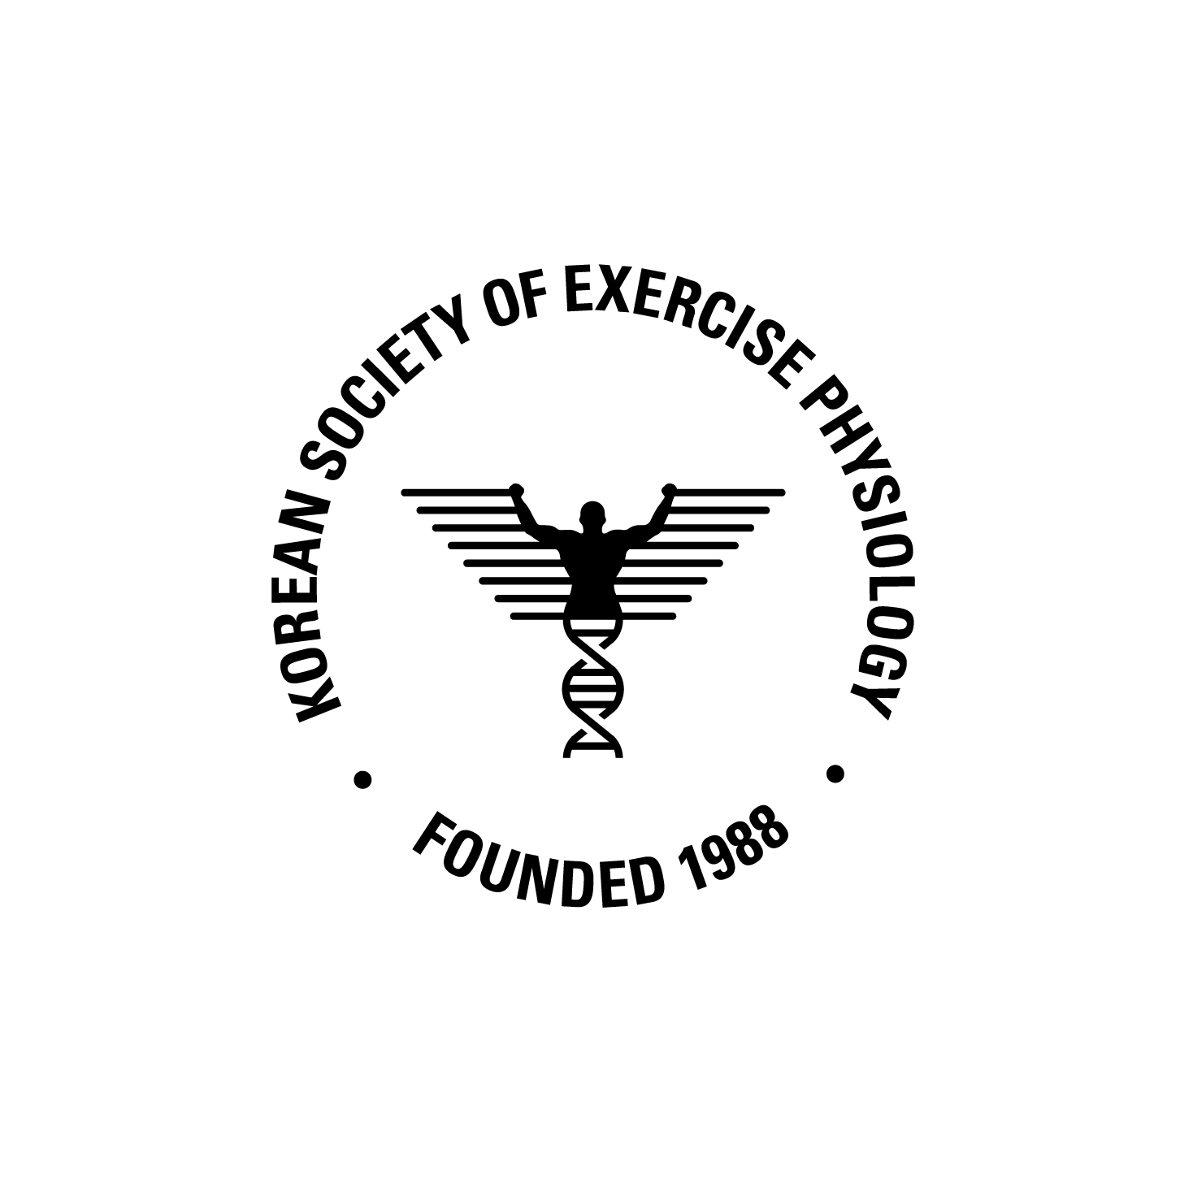Photo
Gil-Dong Hong
Jeju National University
Laboratory of Exercise Physiology

Abstracts_ Please ensure that your abstract contains no more than 300 words. Please avoid diagrams, illustrations, tables, references or graphics in the abstract. Provide maximum relevant information in the abstract and the following structure is obligatory: background, purpose, methods, results, conclusions.

KEYWORDS: Keywords must be 5 or less.
*Email correspondence: abcde@vwxyz.com

